Express Order 2
Feature Report

The second phase of express order adds order of all origin types to the asynchronous order persistence model used in the first phase for quote-like orders and IOC orders. In the asynchronous order persistence model, the transport thread handling the order entry request from a FE puts a persistence request in a queue serviced by one of seven background order persistence thread.

The asynchronous order persistence had opened the possibility of accepting duplicate orders under certain conditions. Consider, for example, a scenario where an IOC order is accepted and quickly cancelled. An order fully cancelled at HTS is removed from order cache by the OHS. Later another order with identical order-id attributes is received. The OHS queries the order cache to determine if an order with identical order-id attributes already exists. If an order is found, the duplicate order is rejected with a DuplicateOrderIdException. The IOC order in this example, however, is not found in the order cache after it is cancelled. So the initial order validation by OHS accepts the order at the entry point. In the synchronous persistence model, this order would have been rejected eventually due to a SQLException while attempting to persist the order. The SQLException is thrown by the database because a uniqueness constraint for a set of order table columns comprising the gang-of-five order-id is violated. With asynchronous persistence, the same SQLException is thrown by the database. However the SQLException in asynchronous order persistence is useless for duplicate order validation as the order has already been accepted. This behavior is encountered currently with IOC orders in production. This behavior is unacceptable when all orders are in asynchronous order persistence mode.

The express order 2 feature avoids accepting duplicate orders while continuing to use asynchronous persistence. This is achieved by adding order-id cache to maintain order-id values of orders that are removed from cache. The added cache does have a limit on the number of order-id values that can be stored. The maximum size of the order-id cache is configurable in OHSOrder.xml. When the cache reaches full capacity, the least recently entered entry in the cache is removed to make room for new entry.

The deleted order-id cache is implemented using LinkedHashMap. While there is no need for a Map to maintain the deleted order-id cache, the LinkedHashMap is a readily available implementation in the JDK with a LRU mechanism by which the least recently entered entry is removed on each new insertion after the Map has reached maximum capacity. Two instances of this Map are used. One instance is a Map<String, String> where the key is string-converted gang-of-five order-id and the value is the same reference as the key. The other instance is a Map<Long, String>. In this case the key is the order’s unique database identifier and the value is the string-converted gang-of-five order-id. For the initial implementation the maximum capacity of the Map instances are chosen to be 1,000,000 to cover 1,000,000 cancelled orders.

Performance Tests Results

Two types of performance tests are executed to determine the benefits and costs of the express order 2 feature. The first test is a standard MCOST test on W_MAIN to measure order response time in low steady order rate. The second test is a new test to study the memory impact of the new deleted order id cache and to study the response time at high rate of customer order/cancel operations.

MCOST Test Results

Two test executions of MCOST were completed on perfbc3b of perf2 environment. One test run was for baseline CD7.1, and the other test run was for baseline plus the express order 2 modifications. The specific load labels other parameters of the test are listed below.

Server: CBOEDIR_COB_INTEG_7.0.77.3
Infra: QAINFRA_TEN_ZERO_9.5.24.1
CAS: Infra 9.5 CASes
Explain Feature: Enabled
OHS Enablement: 50%
Audit Logging: Enabled

Table 1 and Table 2 show the response time at steady 100 order/sec rate for baseline and express order 2 test runs, respectively. The express order 2 improves the order response time by approximately 50%.

Avg. Order Rate (q/s) | Box CPU (%) | OHS CPU (%) | Avg OHS Resp (ms) | Avg. HTS Resp (ms) | Avg. FE Resp (ms) | Avg. CAS logged svr Resp (ms) | Avg. CAS Resp (ms)
~90 | All Proc: 6~8  P.S0: ~5  P.S1: ~5.5 | ~2.5 | 9.2~11.2 | 0.3~0.36 | 10~12 | (perfcas5): 11.6~12  (perfcas10):10~11 | (perfcas5): 11.7~12  (perfcas10): 10~11
Table 1: Baseline test for steady 100 order/sec

Avg. OrderRate (o/s) | Box CPU (%) | OHS CPU (%) | Avg OHS Resp (ms) | Avg. HTS Resp (ms) | Avg. FE Resp (ms) | Avg. CAS logged svr Resp (ms) | Avg. CAS Resp (ms)
~90 | All Proc: ~3  P.S0: ~3  P.S1: ~3 | 0.9~1.0 | 4~6.12 | 0.3~0.36 | 4.8~6.8 | (perfcas5): 5.7~7.6 | (perfcas5): 5.7~7.8
Table 2: Express order 2 test for steady 100 order/sec

Table 3 and Table 4 show the max order rate measured during the step-up part of MCOST for both baseline and express order 2 test runs, respectively. The maximum order rate does not improve very much. This is most probably due to the Explain feature cost becoming more visible during high order rates, thus erasing the benefits of the express order 2. We had noticed during SBT 7.0 performance rollout that at certain order rate threshold the Explain feature leads to heavy system calls and voluntary context switching. The same observations were also made during the customer order/cancel test described later.

Max. Quote Rate (q/s) | Box CPU (%) | OHS CPU (%) | Avg OHS Resp (ms) | Avg. HTS Resp (ms) | Avg. FE Resp (ms) | Avg. CAS logged svr Resp (ms) | Avg. CAS Resp (ms)
~ 447 at 11:45 | AllPrc:36~37  P.S0: 10~11  P.S1: ~49 | 27~28 | 18.4~34.9 | 0.32~0.48 | 21.8~47.6 | (perfcas5): 20.18~49.7  (perfcas10): 25.2~47.1 | (perfcas5): 20~49.8  (perfcas10): 25.2~47.1
Table 3: Baseline step-up test result
Max. Quote Rate (q/s) | Box CPU (%) | OHS CPU (%) | Avg OHS Resp (ms) | Avg. HTS Resp (ms) | Avg. FE Resp (ms) | Avg. CAS logged svr Resp (ms) | Avg. CAS Resp (ms)
~ 468 at 02:26 | AllPrc:~38  P.S0: 10~11  P.S1: ~36 | ~22.3 | 9.85~46.7 | 0.32~0.48 | 12~71 | (perfcas5): 13.1~73.8  (perfcas10): 13~77 | (perfcas5): 13~74  (perfcas10): 13~77
Table 4: Express order 2 step-up test result
The memory characteristics for both baseline and express order 2 test runs look similar.

Customer Order/Cancel Test

This test case is a new one where an attempt was made to inject high rate of customer orders with 100% cancel rate. The goal of this test is to measure the response time at high order rates with the express order 2 and to detect any memory leaks possibly introduced by the addition of deleted order id caches. The input to the test is a steady 300 orders/sec rate with 100% cancel for 60 minutes. At this rate and duration, the total orders would be slightly above 1,000,000 orders.

We had much difficulty in achieving a constant order rate with 100% cancel even at rates as low as 25 orders/second. Two major obstacles were discovered in sustaining high order/cancel rate. The most prominent factor was the GMD channels. The cancel operations for Customer orders involve the use of InternalOrderStatusChannel and OrderStatus channel. The HTS publishes cancel reports on one of 17 IOSC channel. The report is received and processed by OHS, which, in turn, publishes a cancel report on OrderStatus for consumption by StatusServer. Both of these channel types are configured to be “reliable”. When these channels were converted to “Best-Effort”, the tests were able to sustain steady 300 order/sec rate with 100% cancel, however, the response times were still not smooth. This was resolved by disabling the Explain feature.

While the conversion of IOSC and OS channels to best-effort and disablement of Explain feature are unrealistic conditions, these measures helps to achieve comparable results between baseline and express order 2 tests. Ultimately the goal of this test is to test the compare the benefits and costs of express order 2 implementation with the baseline in a high-stress condition.
Both runs of the customer order/cancel test were conducted on perfbc2a with the following parameters.

Server: CBOEDIR_COB_INTEG_7.0.77.3
Infra: QAINFRA_TEN_ZERO_9.5.24.1
CAS: Infra 9.5 CASes

Explain Feature: Disabled
OHS Enablement: 100%
Audit Logging: Enabled
Other: All IOSC channels and OS channel were changed to best-effort

Table 5 and Table 6 show the response times for baseline and express order 2 test runs, respectively. The response times with express order 2 are more consistent and much lower than the baseline.

Box CPU (%) | OHS  CPU (%) | HTS  CPU (%) | Avg. OHS Resp (ms) | Avg. HTS Resp (ms) | Avg. FE Resp (ms) | Avg. CAS Resp (ms)
All Proc: 24~27  PS1: ~25  PS0: ~28.7 | 10.3~13.2 | 4.9~5.1 | Ord: 14.4~35  Xcl: 7.67~18.9 | Ord:0.43~0.58  Xcl: 0.57~0.7 | Ord: 14.1~23.3  Xcl: 7.88~19 | Perfcas5  Ord: 14.1~23.3  Xcl: 1.78~25.5  Perfcas10  Ord: 15.3~25.4  Xcl: 8.6~23
Table 5: Baseline steady 300 orders/sec with 100% cancel

Box CPU (%) | OHS  CPU (%) | HTS  CPU (%) | Avg. OHS Resp (ms) | Avg. HTS Resp (ms) | Avg. FE Resp (ms) | Avg. CAS Resp (ms)
All Proc: ~23.9  PS1: 24.1  PS0: 24.1 | 10.5~11 | ~4.3 | Ord: 2.26~2.88  Xcl: 1.41~1.6 | Ord:0.39~0.42  Xcl: 0.47~0.5 | Ord: 2.88~3.68  Xcl: 1.96~2.23 | Perfcas5  Ord: 2.77~3.14  Xcl: 2.77~3.14  Perfcas10  Ord: 2.5~2.63  Xcl: 2.5~2.63
Table 6: Express order 2 steady 300 orders/sec with 100% cancel
The memory characteristics of OHS for the express order 2 also looked much better than that of the baseline test run. Figure 1 shows the old generation graphs of baseline test run.

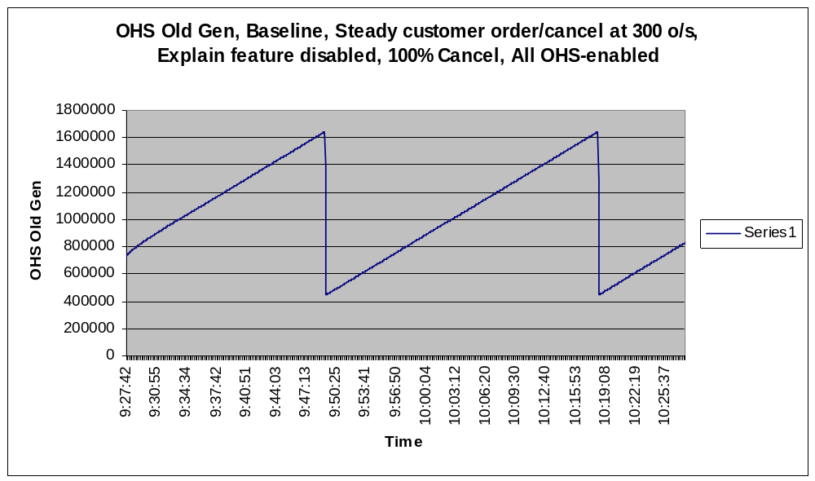
Figure 1: OHS old generation for baseline for steady 300 orders/sec and 100% cancel

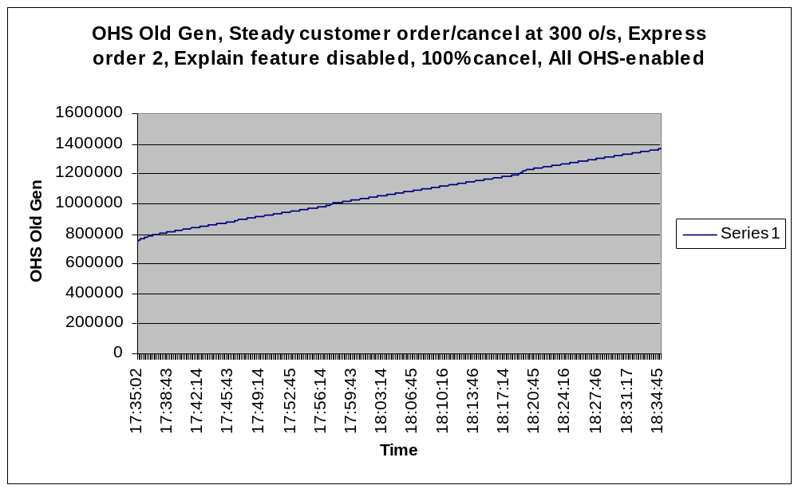
Figure 2: OHS old generation for express order 2 feature for steady 300 orders/sec and 100% cancel
Figure 2 shows the old generation graph of express order 2 test run. Express order 2 test run shows a gradual and slow increase in old generation whereas the baseline shows two major collections in old generation. One theory to explain this is that higher latency times in baseline tests causes higher number of order objects to get promoted before they are cancelled. This builds up the old generation at a much faster rate requiring a couple of collection during the 60 minute test duration.

Figures 3 and 4 show the max chunk graphs for baseline and express order 2 test run of steady 300 orders/sec with 100% cancel.
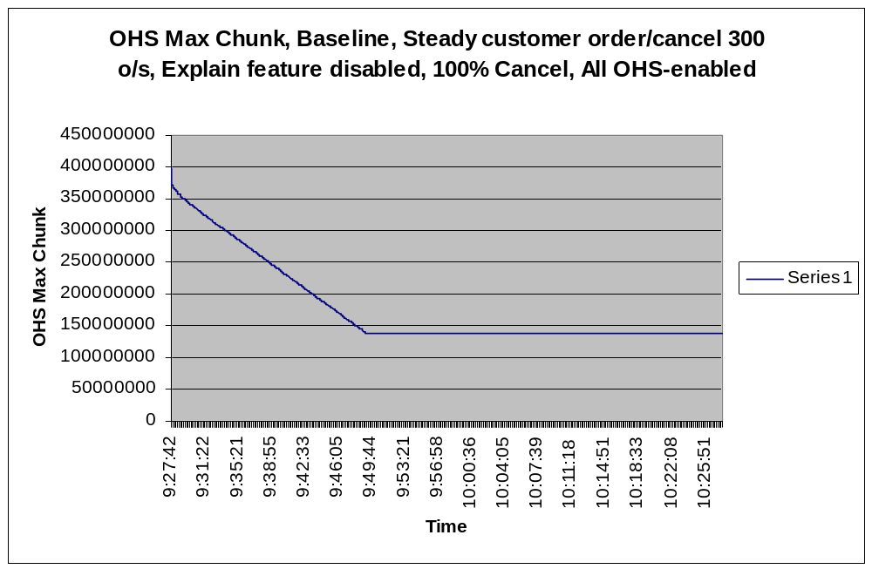
Figure 3: OHS max chunk for baseline steady 300 orders/sec test run
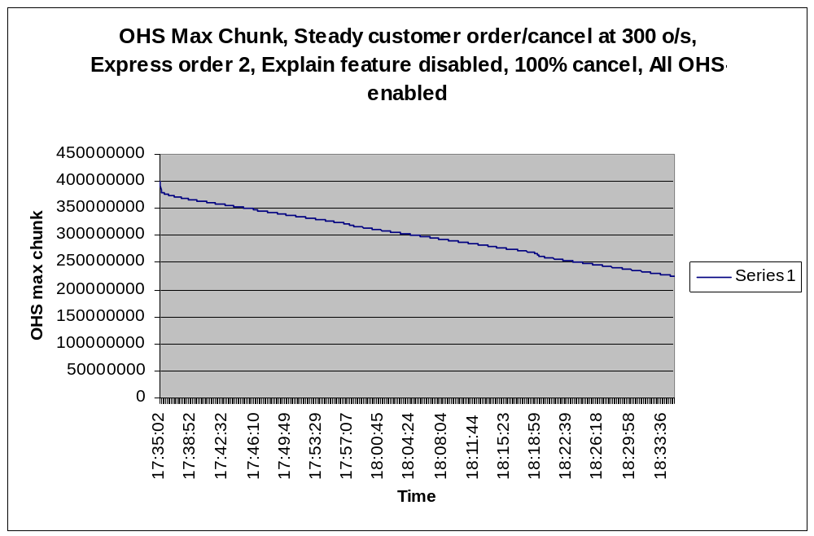
Figure 4: OHS max chunk for express order 2, 300 orders/sec test run

